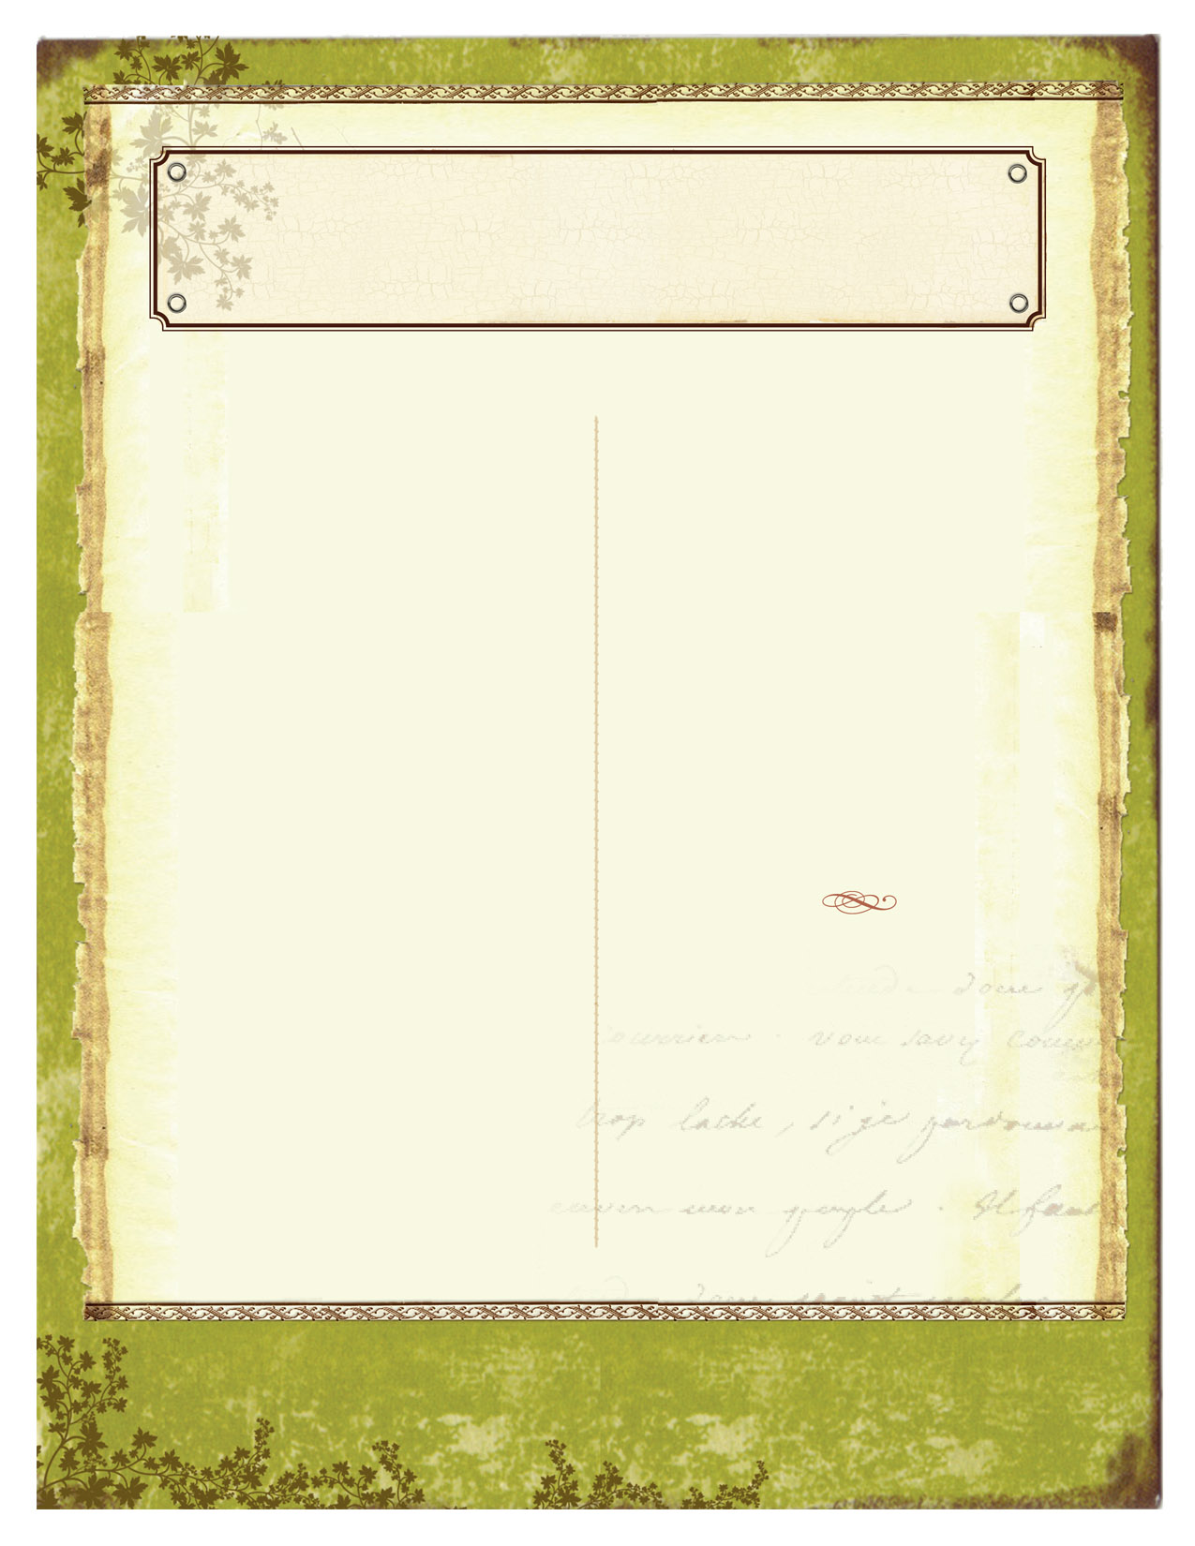

This month in the classroom:

5th Graders are working on a symbol color wheel. The students are choosing a symbol that represents them. They will then put their artwork in a color wheel arrangement.

4th Graders are beginning a project about radial balance/radial symmetry. They are creating a design using origami base folds or a fold of their own making. Each design will be based on a color scheme and have radial balance.

3rd Graders are beginning a new unit on African art. They will be focusing on the art from Ghana. We read a folk tale about Anansi the spider. They will be making a pretend fabric using printmaking and different symbols that are used in Ashanti fabrics but tell the students story.

2nd Grade is working on creating a super leader. Their pictures are self-portraits. We talked about the Seven Habits and how each of them can demonstrate these habits in the things they do around school and at home. By being more conscious of what we do and dong the right thing we are being super.

1st Graders have been making Tar Beach quilts using experiments we made with watercolor. They learned about an artist named Faith Ringgold. She creates her art on quilts and they tell a story with pictures.

Kindergarteners are learning about shapes. We made a shape person and are going to be playing a shape BINGO game. They are also learning how to cut, use glue, and listen.

Around town:

The St Louis Art Fair 2017 will be held in Clayton. It is a free three day art festival. They will have an educational art area for children as well as food and street performers.

AUGUST/SEPTEMBER 2017

The Bulldog Art Room News

CREATIVITY. IMAGINATION. FUN.

VOL. #4 ISSUE #1